Kate Richardson

6 December 2020

Final UDL Project Redesign

UDL Guidelines and Accessibility Redesign

Proposal for a Redesign of a “Malaria” Module for an Undergraduate Course

# Introduction

The Universal Design for Learning (UDL) Guidelines from CAST provide a research-based framework for content creators to design learning experiences that support the development of “expert learners” who are diverse in talents and abilities[1]. Use of assistive technologies is necessary in the creation of accessible learning modules because they “increase, maintain, or improve” the functional capabilities of a student with a disability, according to the Individuals with Disabilities Act (1978). Disabilities are the result of a mismatch between the tasks required of the learner to succeed in the course and the abilities of the learner at the time of interaction (Grant and Perez, 2018). Accessibility for individuals with disabilities is requisite to universally-designed instruction.

In this proposal, I use the UDL guidelines to propose improvements for an undergraduate public health course that would make the module effective for a wider range of learners. Entitled, “Public Health: A Human Perspective,” the target course is an elective within the public health program at Quinnipiac University. Major course outcomes include understand the severity of tropical diseases that mostly affect the poorest and most vulnerable populations in the world and reflect on the importance and complications associated with humanitarian work that combats these diseases. This course was delivered under the “Q-Flex” model, which is a hybrid between remote synchronous and in-person instruction. Additionally, instruction largely follows a “flipped classroom” model. Students consumed the content, electronically mediated by the Blackboard LMS, prior to class meetings which were used for discussion and review. Therefore, many of the redesign suggestions are based on the digital media that contain the course content that students review individually.

The specific target of this redesign proposal was a three week-long module that covers the life cycle, symptomology, discovery of, and history of control attempts of malaria. The course content is entirely composed of lecture videos created by the instructor (with my assistance, as the “Course Designer”). Assignments throughout the module include a reflective journal, a submission of questions, a short essay, and a written exam. In the following section, I discuss accessibility issues associated with the module and discuss several of the proposed improvements.

# Application of Universal Design Guidelines

## Engagement

The first UDL Guideline concerns engagement. The checkpoints assess the extent to which the course design promotes active participation and meaningful connection of the learner to the content, peers, and instructor. The Engagement portion of the UDL guidelines plays a critical role in fostering the development of the autonomous learner.

The unrevised module offers a couple opportunities for engaging meaningfully with the content. One of the assignments is to submit questions directed towards a guest expert on malaria. The best questions are selected by the instructor and delivered during an interview. Students may personalize the learning to a small extent by asking questions they perceive to be most relevant.

Another existing engagement opportunity promotes self-regulation by the opportunity for an open-ended reflection about how one might measure the importance of a disease and its impact on humanity. While the medium of the reflective essay may not be accessible, the exploratory and self-reflective nature of the question facilitates learning because it asks students to express how the content relates to their values and worldview. Such a question implicitly acknowledges the diversity of potential responses, informed by different backgrounds, values, and belief systems. Furthermore, providing reflective opportunities has been shown to improve student success in the course when measured by student perceptions of performance and their final grades (Menekse 2020).

I propose maintaining these reflective exercises in future iterations of the course, because they may serve as a launching pad for further exercises that promote self-regulation. The written reflection in particular may serve as a formative evaluation, because the quality of responses may signal to the instructor and/or course designer the extent to which students have engaged with the material and their level of comfort in expressing their own views. Reflective exercises which simply echo statements from the lecture may indicate a lack of engagement, which could be improved in future modules. On the other hand, thoughtful responses that show evidence of reflection and enthusiasm could signal that the class should be engaging in more thought-provoking exercises and discussions with each other during meetings. Therefore, the reflective exercise not only stimulates the students’ self-regulation, but also may potentially promote a more responsive course design process.

Objectives and theoretical questions that are addressed by the video lectures are prominently displayed in thumbnails; however, in its current state, there is no opportunity for students to express what questions they are most interested in exploring. In a class mostly about obscure tropical diseases, the exceptional notoriety of malaria provides a unique opportunity for recruiting interest. To stimulate self-regulatory processing prior to engaging with the content, I propose introducing a pre-module activity in which the students reflect on their existing knowledge and preliminary questions about the module content. This engagement activity could take the form of a poll conducted during a class meeting prior to the lecture, using a tool called Poll Everywhere. The class may collaboratively generate a word-cloud representing their knowledge about malaria and submit questions that they wish to explore.

In the interest of sustaining effort, I would propose the provision of an alternative to the existing essay question that is more individualized, that requires students to connect to the content through personal research. Below is my suggested alternative assignment prompt:

Select an organization, either non-profit or public, that is combatting malaria. Briefly summarize where the organization is located and their approach to combatting malaria. What obstacles do they face? Given what we have learned in this module, what are the advantages and disadvantages of their approach? How successful do you think this organization/initiative will be in maintaining malaria in this region?

This question addresses the same goals as the existing essay question, with the added benefit of providing a space to explore the students’ unique interests. This exercise may be particularly beneficial to those who have a special interest in a particular region or population that is not specifically addressed in the course.

One more engagement-related design change I would propose is to discuss well-being and the approach to learning the content. To students with limited exposure to the suffering caused by tropical diseases, some of the content could be difficult to process emotionally, which may impact their learning. To proactively support students as they process the material, I would propose holding a discussion— in-person if synchronous, on a discussion board if asynchronous— that provides a forum for students to explicitly discuss strategies for learning difficult material during a difficult time. (The current iteration of the course was taught during the COVID-19 pandemic). A simple think-pair-share discussion module, utilizing breakout rooms if remote, would promote self-regulation by aiding students in monitoring their own emotional state. The class community may share wisdom about learning while coping and coping with learning. Such a discussion during the malaria module would promote a sense of community among the learners and promote potentially shed light on obstacles that are preventing effective engagement with the material. The *malaria* module is an ideal time to engage in such a discussion, because the students will have had three weeks to build community, while they still have the bulk of content ahead of them.

## Representation

The Representation guidelines focus on designing in such a way that allows all students to efficiently decode the information presented in the course materials. The fact that the core course content is almost exclusively video-based in this module is both an advantage and a disadvantage for cognition. Video presentations were selected as opposed to textbook readings or live lectures, because they provide a rich multimedia experience, making full use of both the auditory and visual channels to reinforce key concepts. Furthermore, they contain many interactive quizzes that serve as concept checks, to make the video as engaging as possible. On the other hand, if processing in one of these channels is compromised by disability or circumstance, the video instantly becomes less effective or altogether inaccessible.

The content videos pose problem for learners with hearing impairments. Usually, hearing-impaired learners use captions to understand what is said. There are no captions available in the module in its current state, so provision of captions must be a priority in the redesign of this course. (See section 3a for more details).

Videos also pose challenges to learners with visual impairments because information displayed by the images alone is not accessible. I propose providing a slideshow full of descriptive alt text that contains all the visuals included in each of the videos. In addition, the transcripts should be made available in a searchable file format that is screen-reader friendly, such as a Word document or Google doc. Key words, especially technical vocabulary with difficult spelling and pronunciation, should be included in the alt-text and transcripts.

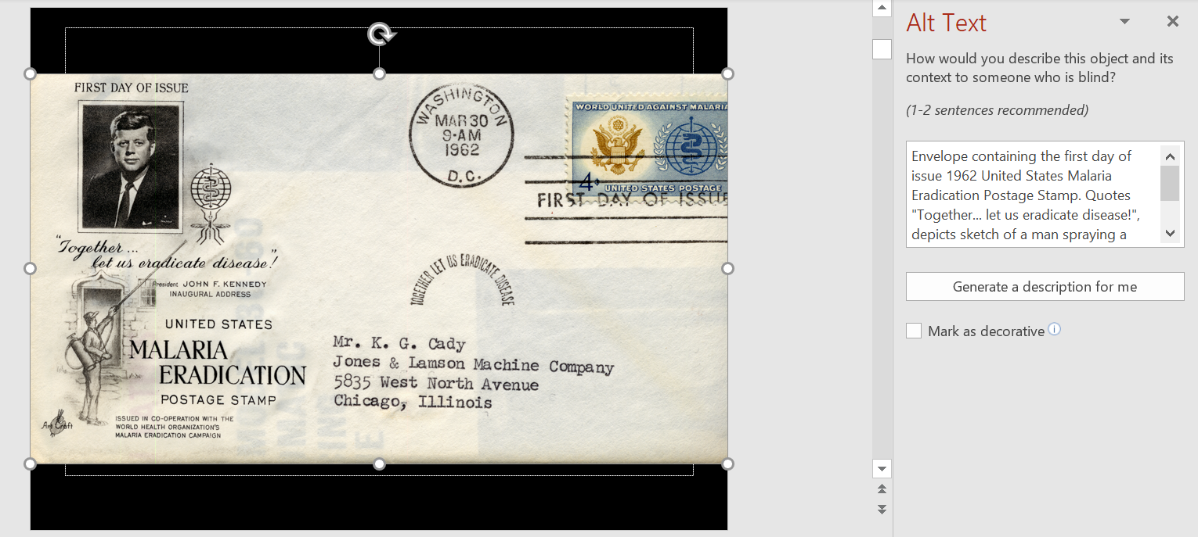Image 1. Powerpoint image containing alt-text.

One of the most challenging aspects of the course is the quantity of technical vocabulary required to demonstrate mastery of the course content. The instructor has noted from previous iterations of the course that students in non-technical majors especially struggle with the scientific jargon and biological processes examined. For example, the malaria life cycle is generally more difficult to grasp for non-biology majors. To address this disadvantage, I propose providing scaffolding in the form of advance organizers and blank charts. The advance organizers may include digital mind maps (see section 3c below). In addition to the transcripts and slideshow with alt-text, a graphic depiction of the malarial life cycle in the form of a concept map could be included without notes as a study aid. The students may fill in with names of each of the stages as they follow along with the video, which enhances generative cognitive processing by directing mental resources towards integrating incoming information with preexisting knowledge (Mayer 2014*)*. In addition, a searchable glossary of terms document may be included, which includes technical vocabulary such as “intermediate host” that is not explicitly discussed in the video but may prevent comprehension to students unfamiliar with the concept.

## Action/Expression

The Action/Expression guidelines seek to develop address a smooth interaction between the learner and the learning interface. When some action is demanded of students, the performance standards must be reasonably accessible to learners of all abilities. As with the Representation guidelines, providing multiple means of expression is essential to designing a universally accessible learning experience.

The *Malaria* module would be significantly improved by providing more options for completion of coursework. Notably, achieving excellent grades in the current version of the module entails strong writing skills. The reflective exercise, discussion question, and essay are all writing-based with no alternatives. As such, if the student experiences some obstacle to writing, they will have no way to effectively demonstrate their mastery of the content without strain. This is an example where the goal of the modules has been conflated with the demands of the means to achieve them.

A straightforward way to provide options to written work is to keep the prompts but allow submission of alternative media in lieu of written work. The reflective exercise may be just as well expressed through a voice recording, a concept map, or a video response. Students can easily upload either an mp3 (voice file) or mp4 (video recording) as an attachment to their journal entry. Accepting alternative formats accommodates students who may be doing online work with a mobile device, where typing out long responses is more difficult than for students who are equipped with a laptop or desktop. Students may also prefer to record journal entries if they are dyslexic or have impaired mobility, Since Blackboard is already capable of submission of different file types, fulfilling this checkpoint is simply a matter of allowing and encouraging students to do so.

The written essay constitutes a large portion of the exam grade (20%). The goal of the written essay is to demonstrate their understanding of the complexities of combatting malaria and to identify pros and cons of different approaches. Since this goal is unrelated to writing ability, it is especially appropriate in this case to apply an alternative way to express knowledge. I propose accepting submissions in the form of a concept map (see the section on Mindomo, below) or a narrated presentation. By allowing students to choose the medium that works best for them, they may focus on content rather than delivery.

Part of the formative assessment grade may also be given to contribution to a Wiki. By rewarding participation in this way, at least a part of the assessment does not rely on a sharp memory or previous knowledge. Using contributions to a class wiki as an assessment alternative provides several advantages: students may use their own strengths to contribute to the group’s success—either through writing, providing illustrations or images, creating diagrams, drawing mind maps, or editing, depending on their abilities at the time. Collaborative wikis also contribute to creating a class community and encourage students to reflect on their own strengths and knowledge gaps.

I have chosen in my redesign not to do away with the multiple-choice assessment completely since many of the module goals are *recall* and *identify* goals, but I would diminish the importance of the multiple-choice assessment in determining overall student performance. To make the multiple-choice exam as accessible as possible, students should be able to use assistive technologies such as screen readers and alternative keyboards. I would also propose that they can use their own study guides, which are to be submitted along with the test, to reduce the burden imposed by the copious amount of memorization of technical vocabulary. Questions should be novel and focus on the meaning of the concepts and transfer knowledge. With these improvements, the summative evaluation of student performance would be as accessible as possible and encourage students to fulfill the learning objectives related to fluency of key terms and concepts in the domain of public health.

# Assistive Technologies in Support of UDL

Implementation of select digital tools and technologies are indispensable to the creation of accessible web-based content. Several resources that can be especially relevant to the *Malaria* module are listed below.

## Closed Captioning

Although media-rich video-based content can play a role in universally designed lessons, one challenge this medium presents is conveying the auditory content to learners with hearing impairments. The challenge posed by the auditory information is exacerbated when the mouth of the presenter is not visible, such as during voiceover narration, because lip-reading is impossible. Closed captioning[2] is an assistive technology that eliminates this barrier through written descriptions of all meaningful content. This tool is another iconic example of how designing for learners with disabilities in mind benefits all learners. For example, those without hearing impairments may benefit from closed captioning when in noisy environment. Learners who struggle with spelling or decoding speech benefit from seeing novel vocabulary spelled out while they are listening. Subtitles and closed captioning may especially benefit ESL speakers, who face a higher cognitive demand because they are processing the material in their second or third language. A study conducted by Lin et al. found that videos explaining scientific concepts conducted in English with subtitles decreased cognitive demands and increased performance for ESL learners (2016). Closed captioning offers many benefits and no disadvantages because users always have the option of hiding the text if desired.

While many video platforms, such as YouTube, provide this resource automatically on most video, Techsmith Knowmia, the content sharing platform used by the *Malaria* module, does not. The video creator must provide the captions either by enabling the text-to-speech software in the video settings of the platform, or by creating their own in the video editing process. As a result, hastily prepared videos hosted on Knowmia frequently lack closed captioning, as is the case with the *Malaria* module.

I propose adding closed captioning to the existing files using Camtasia’s built in tool dedicated to this purpose, Knowmia’s text to speech features, or both. For those videos that contain a script, the entire text should be synced to the video directly in the source Camtasia project and reuploaded. For videos whose source files are lost or that lack a script, the text to speech software in Knowmia can generate automatic captions, which could then be manually corrected for grammar and readability.

## Mindomo: Mind-mapping Software

Mind maps, or concept maps, are a graphical representation of the relationships between concepts. They can be used as an educational tool by either instructors who seek an alternative and sophisticated way to present information and the structure undergirding it, or students, who wish to actively and visually organize their knowledge as they are learn. In 1991, Joseph Novak, a science educator firmly rooted in the new educational philosophy of constructivism, sought “to determine whether or not concept maps can make science conceptually transparent to teachers and, in turn, to their students.” He argued that knowledge is built by incorporating new information into preexisting knowledge, and that the focus of science education should shift from rote memorization to clarifying relationships and constructing. He then popularized the use of concept maps to facilitate this process. (Novak 1991). Indeed, a study that investigated the benefits of concept mapping in engineering students found that use of concept maps significantly improved the average grade on a transfer test (Martinez et al. 2013).

Concept maps may be considered an assistive technology because they have the potential of reducing certain barriers. Students who are asked to express what they know through expository writing may produce work that does not accurately reflect their mastery of material, because too many cognitive resources have been spent on organization, planning, physical action, or spelling that is associated with writing. Concept maps present an opportunity for students to generate deliverables that reflect their working knowledge of the material.

The specific concept mapping tool I propose implementing in the course is Mindomo[3]. This software is especially suited to undergraduate students who may be working from a variety of devices, because this app supports a wide range of platforms; it has mobile apps, desktop app, and web-based versions. If the software is purchased for the entire class, students do not need to make an account, and the mind maps may be directly embedded into and edited from the Blackboard LMS.

Mindomo may also be used as a collaboration platform or time management tool; Gantt charts allow users to set deadlines on action items they create within the concept map. They may also be used to plan and manage group work. In addition to text, the nodes of the maps may include images, links, voice recordings, and videos, so students always have options about how to express their knowledge. Through the Blackboard integration, it is also possible for the instructor to assign work on the map, track individual contributions, and grade student work.

I propose using Mindomo in the *Malaria* module as an alternative to the written portion of the exam. Instead of verbally justifying their positions, students would illustrate their reasoning through illustration of the hierarchical relations between their supporting arguments. The “essay” question would still be graded on quality of argumentation and appropriate use of supporting evidence.

I also propose using Mindomo concept maps as advance organizers. Skeletal mind maps, such as the one below, should be provided prior to the presentation of the course material (i.e., closer to the top of the module page on Blackboard). Students who desire extra scaffolding for their notetaking could download the mind map, then add and modify information as they proceed through the module content. They can then share their mind map on the discussion forum to seek feedback and review notes with their classmates. 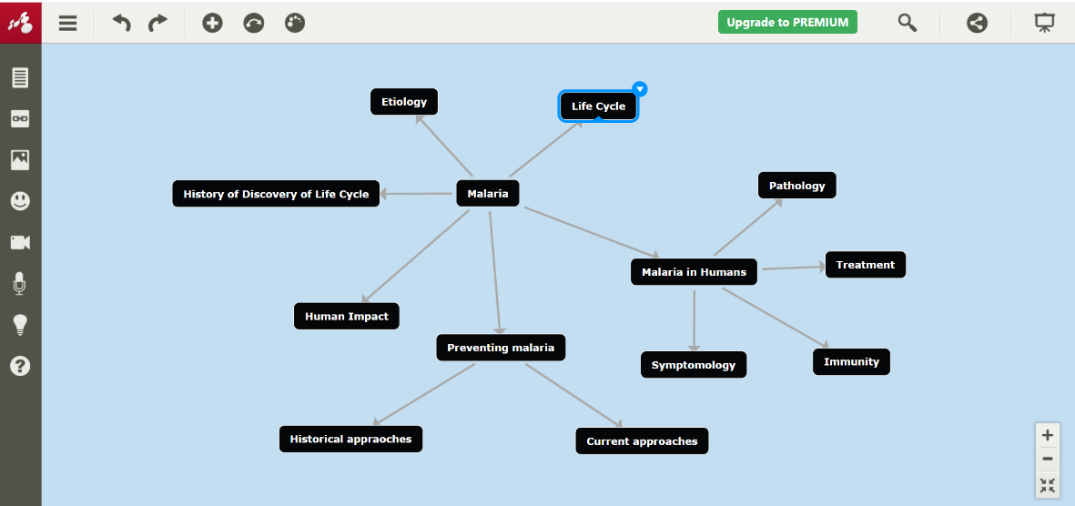 Image 2. Proposed Mindomo concept map advance organizer

Mind maps are a versatile tool that may provide supports for students who would benefit from an alternative to long-form written assignments. They can also serve as advance organizers to support efficient processing of the course material. In the *malaria* module, Mindomomay be used to accomplish both.

## Blackboard Ally

Blackboard Ally[4] is an assistive technology service that renders course materials distributed through the Blackboard LMS in more accessible and alternative formats. If the institution has licensed use of Blackboard Ally, all content uploaded to the LMS page is automatically evaluated for accessibility. Feedback is provided to the course developers about specific improvements that could be made to make the content as accessible as possible. For example, it detects missing alt-text in slideshow presentations, or assesses uploaded readings for screen reader compatibility. Additionally, institutional reports are generated using aggregate data that provide insight into students’ preferences and needs.

Blackboard Ally would be useful for the *Malaria* module after supporting documents have been uploaded. My design proposals outlined in the UDL Guidelines include the provision of supporting documentation for the videos, including slideshow versions of the content videos that provide extended alt-text, glossary of terms with varying levels of organization, and video transcripts. All these additions, to fulfill their purpose as contributing to a course designed for learners of all abilities, would themselves need to be in accessible formats. Integration of Blackboard Ally would ensure that the instructor has an efficient way of identifying potential accessibility issues with this content. It also provides many options for the conversion of documents to alternative formats according to individual choice, such as a mp3 file using text-to-speech, translated versions, or an ePub for documents that are compatible with screen readers.

Integration of Blackboard Ally would provide a sustainable way to monitor accessibility as the course materials are updated. However, instructor access entails implementation on the institutional level. Therefore, I would appeal to the institution’s administrators to purchase this software.

# Conclusion

Upon successful implementation of my suggested improvements inspired by CAST’s UDL guidelines, the *malaria* module would be more engaging, more germane to efficient learning, and more accessible. My proposed improvements include an alternative assessment that develops students’ pre-existing skills and interests, which would enhance engagement. The provision of closed captioning and advance organizers make the materials more accessible by increasing types of representation of the content. Expansion of the options for demonstration of knowledge beyond writing, such as mind maps or videos, would enable expression and communication for diverse learners. Assistive digital technologies that could be used to implement these changes include Techsmith’s captioning software, Mindomo’s concept mapping tool, and the Blackboard Ally LMS plugin that monitors accessibility status of course materials. The proposed improvements would ensure that the *Malaria* module is meaningful and effective for learners of a much wider range of levels and abilities.

# Works Cited

Alison. 2018, December 18. *Subtitles vs. Captions: What’s the Difference?* Accredited Language Services. <https://www.accreditedlanguage.com/subtitles-captions/subtitles-and-captions-whats-the-difference/>

Grant, Kendra and Perez, Luis (2018) *Dive into UDL : Immersive Practices to Develop Expert Learners* (1st ed.) International Society for Technology in Education.

Individuals with Disabilities Act of 20 USC § 300.5 (2017)

John J. H. Lin, Yuan-Husan Lee, Dai-Yi Wang, & Sunny S. J. Lin. (2016). Reading Subtitles and Taking Enotes While Learning Scientific Materials in a Multimedia Environment: Cognitive Load Perspectives on EFL Students. *Journal of Educational Technology & Society,* *19*(4), 47-58. Retrieved December 2, 2020, from <http://www.jstor.org/stable/jeductechsoci.19.4.47>

Martínez, G., Pérez, Á, Suero, M., & Pardo, P. (2013). The Effectiveness of Concept Maps in Teaching Physics Concepts Applied to Engineering Education: Experimental Comparison of the Amount of Learning Achieved With and Without Concept Maps. *Journal of Science Education and Technology,* *22*(2), 204-214. Retrieved December 2, 2020, from http://www.jstor.org/stable/23442287

Mayer, R. (2014). Cognitive Theory of Multimedia Learning. In R. Mayer (Ed.), *The Cambridge Handbook of Multimedia Learning* (Cambridge Handbooks in Psychology, pp. 43-71). Cambridge: Cambridge University Press. Doi:10.10117/CBO978113975247369.005

Muhsin Menekse (2020) The Reflection-Informed Learning and Instruction to Improve Students’ Academic Success in Undergraduate Classrooms, *The Journal of Experimental Education*, 88:2, 183-199, DOI: [10.1080/00220973.2019.1620159](https://doi-org.libraryproxy.quinnipiac.edu/10.1080/00220973.2019.1620159)

Novak, Joseph (1991). Clarify with Concept Maps. *The Science Teacher,* 58:7, 44-49

1. <http://udlguidelines.cast.org/>
2. Closed captioning refers to text that captures all sound effects in addition to dialogue, geared toward deaf or hard-of-hearing individuals. Subtitles are created with the intention of translating to another language (Alison. December, 2018). In the context of educational videos referred to in this proposal, they are interchangeable.
3. Product information may be viewed at <https://www.mindomo.com/dashboard>
4. See <https://ally.ac/index.html> for product details